**1) what are three main characteristics of a** **MOSFET compared to a bipolar junction transistor**

~~a) The FET construction does not have a PN junction in its main current carrying path, which can be made from an N-type or a P-type semiconductor material with high resistivity. While the basic construction of a BJT is two PN junctions producing three terminals.~~

~~b) A BJT has an emitter, collector and base, while a MOSFET has a gate, source and drain.~~

~~(The three leads of a FET are the Source (S), Drain (D) and Gate (G), with Source and Drain forming the ends of the channel and the Gate controlling the channel conductivity. While the three terminals are identified as the Emitter or E, the Base or B and the Collector or C.)~~

~~c) BJTs are preferred for low current applications, while MOSFETs are for high power functions.~~

<https://www.westfloridacomponents.com/blog/transistors-what-is-the-difference-between-bjt-fet-and-mosfet/>

<http://www.differencebetween.net/technology/difference-between-bjt-and-mosfet/>

[**http://www.webpoliteh.ru/subj/ore/405-5-3-ekvivalentnaya-sxema-bipolyarnogo-i-polevogo-tranzistorov.html**](http://www.webpoliteh.ru/subj/ore/405-5-3-ekvivalentnaya-sxema-bipolyarnogo-i-polevogo-tranzistorov.html)

[**http://studopedia.org/11-82548.html**](http://studopedia.org/11-82548.html)

Спрашивают полевой в сравнении с биполярным:

У полевых транзисторов:

1. Много выше входное сопротивление (на несколько порядков)
2. Меньше паразитные ёмкости, что позволяет их использовать на более высоких частотах (до мегагерц) page7
3. Биполярный всегда нормально закрыт, В то время как полевой может быть как нормально открыт (встроенный канал), так и нормально закрыт (индуцированный канал)
4. Более чувствительны к различного рода предельным нагрузкам пульсациям и т.р., что требует более аккуратных схем защиты
5. Меньше уровень собственных шумов, что позволяет их использовать во входных цепях высокочувствительных схем и измерительных усилителях (instrumental amp.)

Field-effect transistors have:

1) Much higher input resistance/impedance (several orders of magnitude)

2) Less parasitic capacitance, which allows them to use at higher frequencies (up to megahertz) Page7

3) Bipolar always normally closed, while in the FET can be either normally open (internal/inserted channel) and normally closed (induced channel)

4) more sensitive to various types of extreme stresses, pulsations and so on, which requires more accurate protection schemes

5) Less noise level that allows them to be used in the input circuits of highly sensitive schemes and measuring amplifiers (instrumental amp.)

**2) what is the threshold voltage of a MOSFET (Floyd, page 359)**

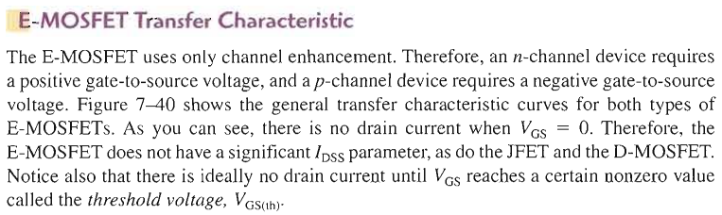

Пороговое напряжение – такое, при котором транзистор открывается, т.е. появляется ток (последнее предложение в абзаце выше). Threshold voltage - one in which the transistor is opened, meaning a current appears

**3) what is the equivalent circuit of a MOSFET**

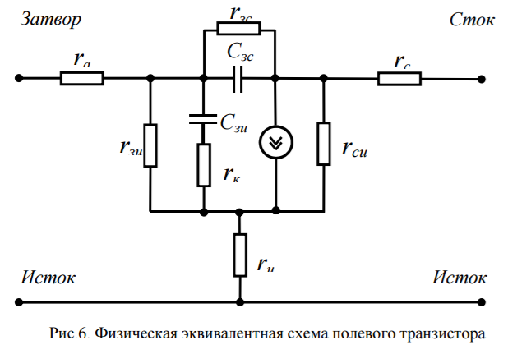**Затвор – Gate, Сток – Drain, Исток - Source**

<https://ocw.mit.edu/courses/electrical-engineering-and-computer-science/6-012-microelectronic-devices-and-circuits-fall-2005/lecture-notes/lec11.pdf>

<http://ikit.edu.sfu-kras.ru/files/7/4.pdf>

<http://www.unn.ru/books/met_files/tikhov.pdf>

**4) what is the input stage of an op-amp**

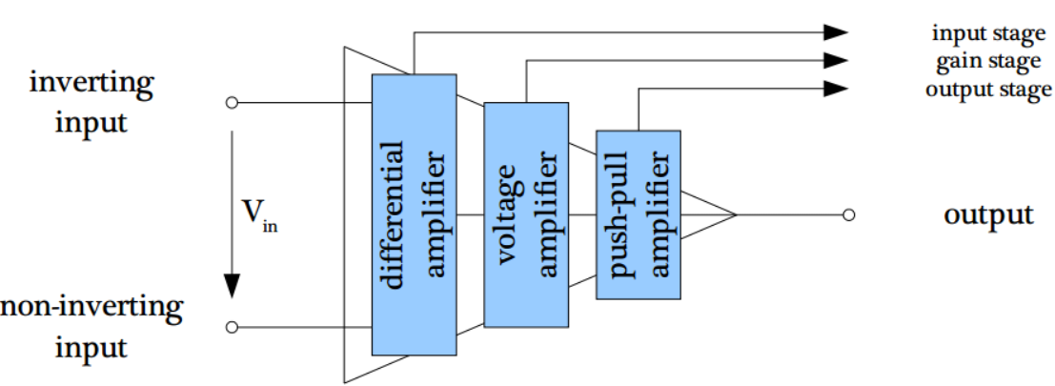

Differential amplifier basic operation:

*input stage provides common-mode rejection

*output is proportional to the difference of two inputs

A differential amplifier is the combination of inverting and non inverting amplifier. A differential amplifier is a type of electronic amplifier that amplifies the difference between two input voltages but suppresses any voltage common to the two inputs.

**5) which operation modes does the input stage of an op-amp have (**Lec chap 3.1 page 13**)**

Modes of signal operation:

* common-mode input

*common-mode rejection ratio

**6) calculate the input bias current if both input currents are given**

Input bias current (I bias)

*the input bias currents are the base currents of the differentia l amplifier

*by definition, the input bias current is the average of both input currents and is calculated as follows:

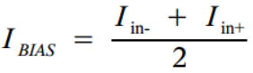

**7)** **calculate the reference voltage for a given input voltage divider of a comparator**

reference != threshold

reference voltage – usually connected to comparator’s input in form of voltage divider обычно подается на вход компаратора в виде делителя напряжения.

**8) what is the basic circuit of a op-amp differentiator**

* an op-amp differentiator has a capacitor at the input

* the output voltage is proportional to the slope of the input voltage

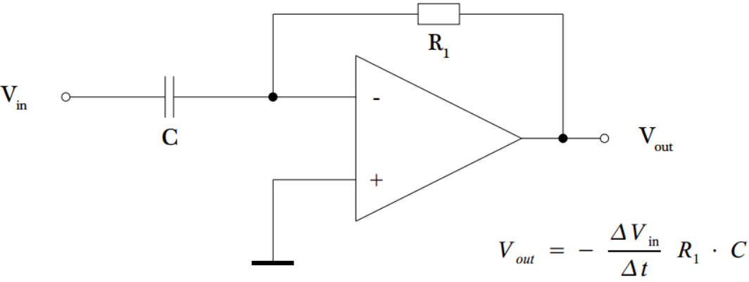

**9) calculate** **the cut-off frequency of an op-amp first order low-pass filter**



<http://analogiu.ru/6/6-5-2-1.html>

**10) what is the basic circuit for a LED (**Или (чаще) источник тока**)**

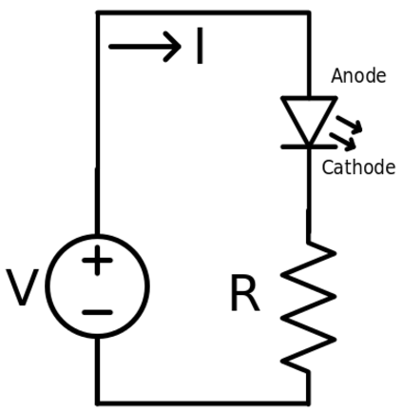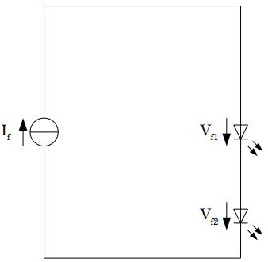 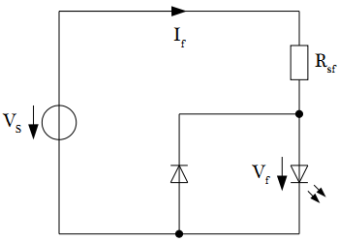

**11)** **what is the characteristic curve of a photodiode** (Зависимости выходного тока от напряжения при разных уровнях освещенности) Look in lecture notes p.36 – it’s a characteristic curve

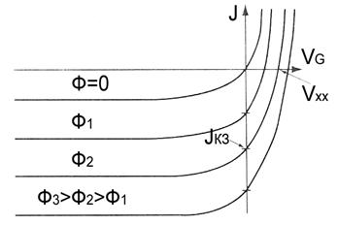

**12)** **what is the basic circuit for a phototransistor** (are both circuits basic? Yes)

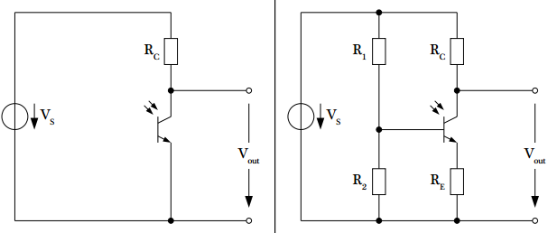

**13)** **what is the CTR of an opto coupler (just formula)**

 CTR -> current transfer ratio

**14)** **calculate the** **input series resistor (E/R во втором графике снизу) for an opto coupler (missing details like numbers?)**

<http://forum.cxem.net/index.php?/topic/116572-%D1%80%D0%B0%D1%81%D1%87%D0%B5%D1%82-%D1%80%D0%B5%D0%B7%D0%B8%D1%81%D1%82%D0%BE%D1%80%D0%B0-%D0%B4%D0%BB%D1%8F-%D0%B4%D0%B8%D0%BE%D0%B4%D0%B0-%D0%BE%D0%BF%D1%82%D0%BE%D0%BF%D0%B0%D1%80%D1%8B/>

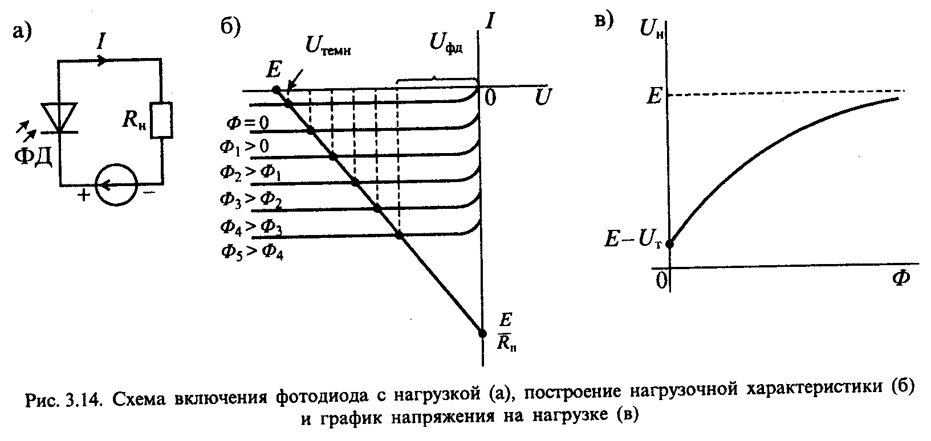

**15) calculate the RMS value of the output current of an opto coupler if a sinusoidal input signal is applied**



**Первый равен просто ξ, второй равен 0.5sin(2ξ), дальше просто подстановка верхних и нижних пределов**

**1. Operational Amplifier – Basics**

• **What is the right symbol labelling of an operational amplifier?**

Спросить у профессора, разрешено ли более одного ответа? Или надо non-inverting and inverting вместо positive and negative?

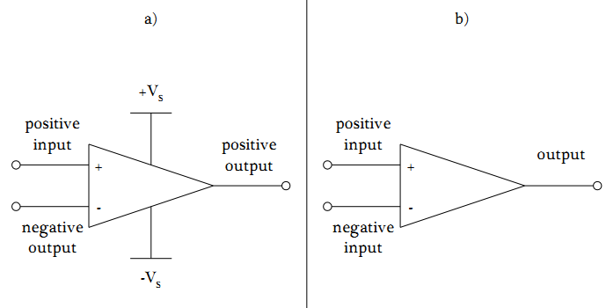

• **What has to be inserted between the positive input and the negative input to model a real operational amplifier?** An input resistor, ~~output res, and controlled current source~~

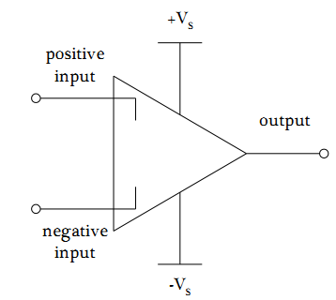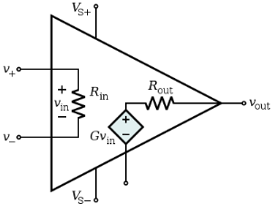

• **What is not part of an operational amplifier?**

a) Differential Amplifier

b) Current Amplifier ----->>>> not part

c) Push-Pull-Amplifier

**• What is wrong?**

~~Maybe positive and negative inputs should swap places~~ (does not matter) and they should be called non-inverting and inverting respectively????????????? maybe

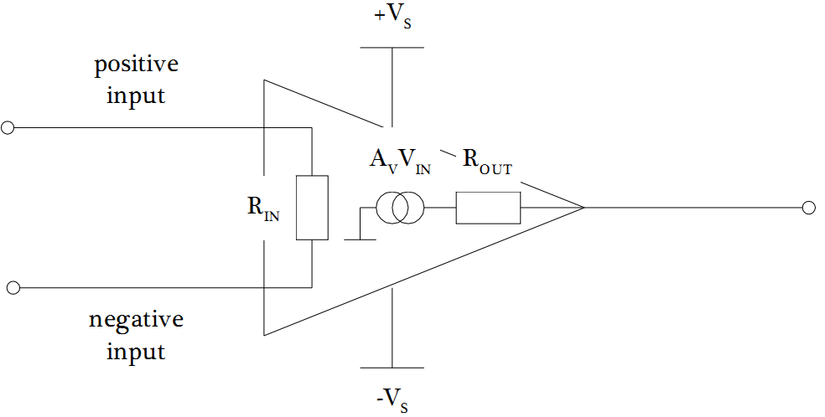

**• What is wrong or missing?** --->>>> the Av*Vin source and maybe non-inverting and inverting

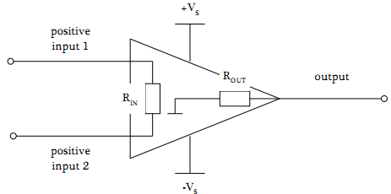

**• What is typical for a real operational amplifier?**

a) RIN is very high and ROUT is very low --->>>> right

b) RIN is very low and ROUT is very high

c) RIN is very high and ROUT is very high

d) RIN is very low and ROUT is very low

**• What is typical for an ideal operational amplifier?**

a) Rin -> infinity, Rout -> 0 ---->>> correct

b) Rin -> 0, Rout -> infinity

**• What is the type of amplification for the gain stage of an operational amplifier?**

a) Voltage Gain ---->>> correct

b) Current Gain

**• What is NOT typical for a real operational amplifier? Получается, разрешено выбирать несколько ответов?**

a) RIN is very high and ROUT is very low

b) RIN is very low and ROUT is very high --->>>> **NOT typical**

c) RIN is very high and ROUT is very high --->>>> **NOT typical**

d) RIN is very low and ROUT is very low --->>>> **NOT typical**

**• What is part of the input, gain and output stage of an operational amplifier?**



**2. Operational Amplifier – Differential Amplifier Part I**

**• What type of operation mode is shown?**

Comparator with zero reference voltage (on line to -)

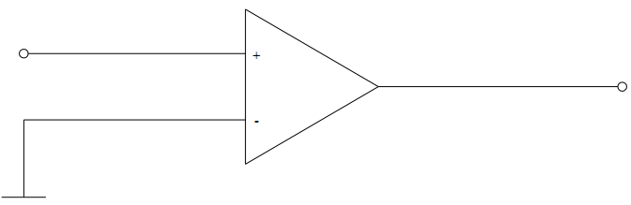

**• What is the value of the output voltage Vout in the circuit?**

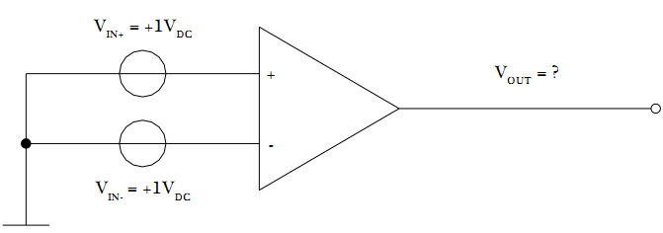 

**Проще такую формулу (инверсия, т.е. знаки, применяется только к V, а у самих величин не трогаем знаки)**

Vout = (Vin+) – (Vin-) = 1 -1 =0 V Ноль будет только для идеально ОУ. Для реального будет некое напряжение, характеризующее несимметрию входов. Page 16

**• What are the four operation modes of an operational amplifier?**

single-ended input

double-ended input (differential input)

common-mode input

comparator

~~common-mode rejection ratio –~~  a parameter, not a mode

**• How is the definition of the CMRR?**

The measure of an amplifier's ability to reject common-mode signals is a parameter called the common-mode ejection ratio (CMRR). The ratio between the differential gain Avo(d) and the common-mode gain ACM is the

common-mode rejection ratio CMRR

**• What is the definition of the CMRR and what does the CMRR mean?**



**• Which mode is not part of an operational amplifier?**

a) single ended

b) common mode

c) open collector mode ---->>>> not part

**• What has to be inserted at the positive input to get a single ended mode?**

Usually a resistor is inserted to level input current offset. For ideal V.S. – simply to ground (Обычно вставляют резистор, чтобы уравнять входные токи смещения. Для идеального ОУ - просто на землю)

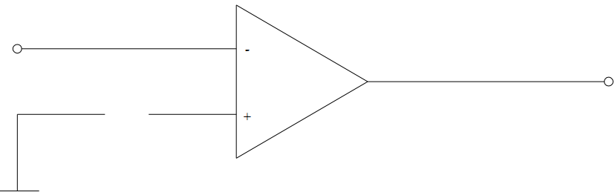

**• What is wrong?**

a) The CMRR describes the rejection of the amplification of input signals with a phase shift of zero.

b) The CMRR describes the rejection of noise at the input. -->>wrong Только СИНФАЗНЫЙ шум, т.е. тоже не совсем верно

c) The CMRR describes the rejection of noise at the output resulting from the input signals. -->>wrong

**• What is the value of the output voltage VOUT?**

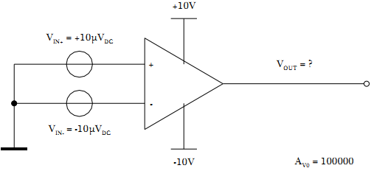Vout=Av*[ (Vin+) – (Vin-) ] = 100000*(10uV + 10uV) = 2V

**3. Operational Amplifier – Differential Amplifier Part II**

**• Calculate the value of the output voltage:**

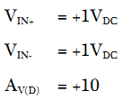Vout = Av * [ (Vin+) – (Vin-) ] = 10 ( 1 – 1) = 0 V 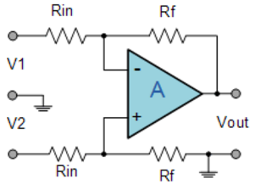

<http://www.electronics-tutorials.ws/opamp/opamp_8.html>

**• Calculate the value of the output voltage:**

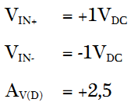 Vout = Av * [ (Vin+) – (Vin-) ] = 2.5 * ( 1 + 1) = 5 V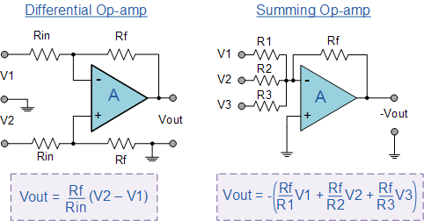

**• Calculate the value of VIN+:**

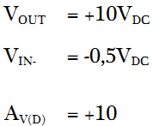Vin+ = (Vin-) + (Vout /Av) = (-0.5) + (10/10)=0.5

**• Calculate the value of the differential input voltage:**

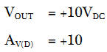

Vout = Av * Vin => Vin = Vout/Av = 10/10 = 1 V

**• Calculate the CMRR:**

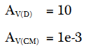

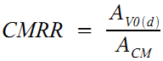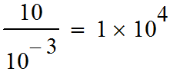 if in dB: 20*log(10^4)=80dB

**• Calculate the amplification gain for the common mode:**

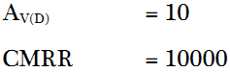 Acm=Av(d) / CMRR = 10 / 10000 = 0.001

**4. Operational Amplifier – Parameters**

**• Which influence is described by the Input Offset Voltage Drift?**

The input offset voltage drift is a parameter related to VOS that specifies how much change occurs in the input offset voltage for each degree change in temperature

**• Which is not a parameter of an operational amplifier?**

a) Input Resistance

b) Input Bias Current 🡨 (not a parameter) задается внешней цепью – не параметр самого усилителя

c) CMRR

**• Which is a parameter of an operational amplifier?**

a) DC current gain

b) Threshold voltage

c) Input Offset Current ----->>>> a parameter

**• Which environmental parameter influences the Input Offset Voltage of an operational amplifier?**

the input offset voltage drift is a parameter related to Vos that specifies how much change occurs in the input offset voltage for each degree change in temperature

**• Calculate the Input Bias Current:**

**I+ = +1µA**

**I- = +1µA**

 ( 1 + 1 )/2 = 1 µA знак для значений не меняем

**• How is the slew rate of an operational amplifier defined.**

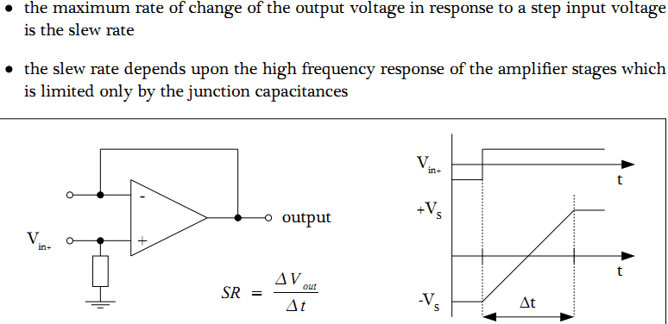

**• Calculate the value of the Input Offset Current:**

**=**|-1.25uA-2uA|=3.25uA

**• Calculate Vout:** ????????????????? вроде как можно игнорировать питание при составлении формулы

Нельзя! На выходе будет как раз 10В, т.к. это режим компаратора. Т.е. усилитель перейдет в режим насыщения. (не может там быть на выходе 10^5!) **The output will be 10 V because** 

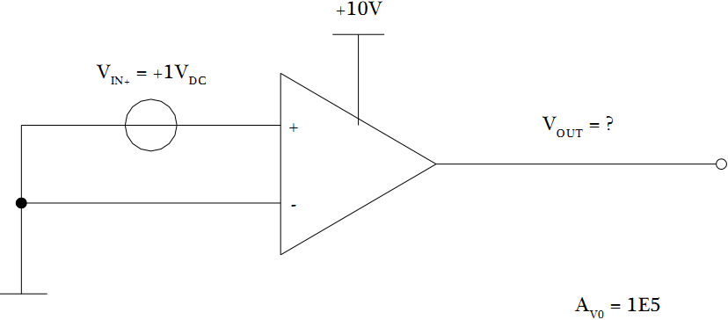

**5. Operational Amplifier – Basic Circuits Part I**

**• What is the right non-inverting amplifier?** (b)

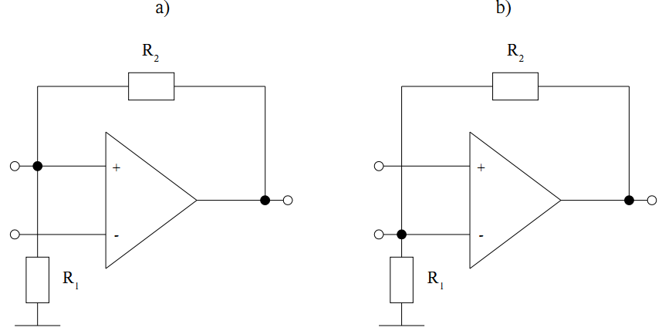

**• Which type of feedback is right for stable operation?** (b)

~~A (в случае(B)из-за отсутствия резистора будет менее стабильным)~~Нет! Нужна отриц. ОС, т.е. с выхода на вход(-)

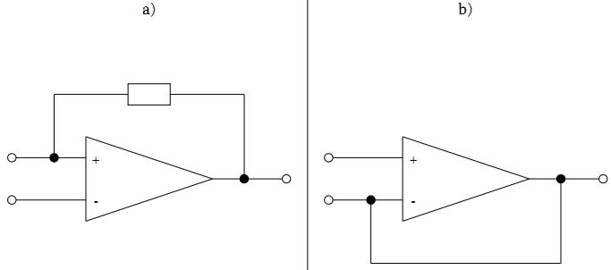

**• Draw a non-inverting amplifier:**

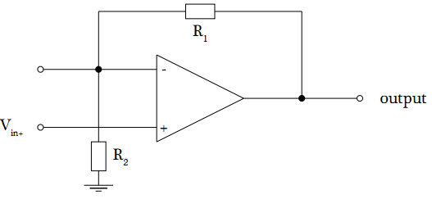 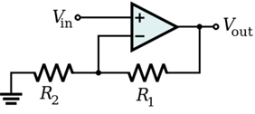

**• What is the voltage gain of a non-inverting operational amplifier:**

 **Vout/(R1+R2) = Vin/R2 Vout/Vin=Av Av=(R1+R2)/R2=1+R1/R2**

**Calculate the value of the feedback resistor:**

**AV = 11**

**R1 (input resistor) = 1000 Ohm**

R2=R1(Av-1)=1000(11-1)=10000 Ohm

**• Calculate the closed-loop voltage gain of a non-inverting amplifier:**

**Input Resistor = 1kW**

**Feedback Resistor = 9kW**

 (for left circuit above) Av = 1 + (9 / 1) = 10

**6. Operational Amplifier – Basic Circuits Part II**

**• Draw an inverting amplifier:**

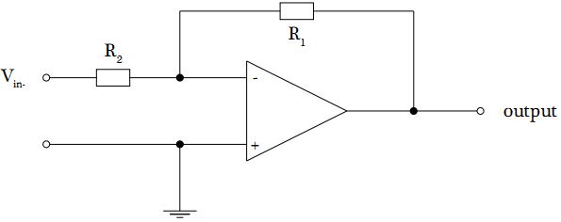

**• By using which method an inverting operational amplifier circuit can be analysed?**

Probably method of equivalent circuit

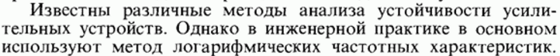

**• Calculate the value of the input resistor:**

**AV = -10**

**R2 (feedback resistor) = 10000 Ohm**

R1 = - (R2 * Av) = - [ 10000 / (-10) ] = +1000 Ohm

**• What is wrong?**

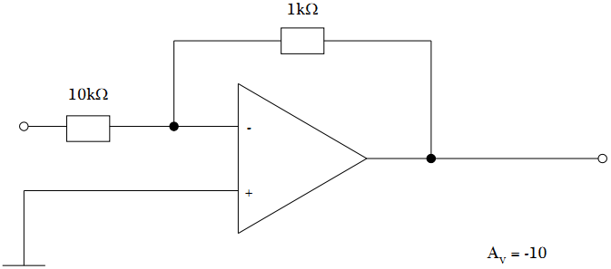Since  => Av is actually (-1/10)

**• What has to be inserted at the positive input to create an output offset voltage of 2.5V?**

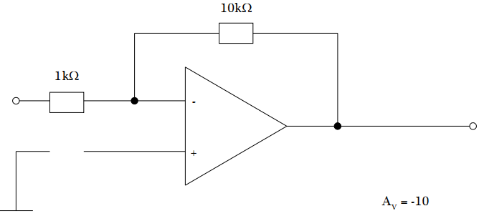Voltage source --->>> 2.5* (1/(1+10)) ≈ 0.23V

**• Calculate the output offset voltage:**

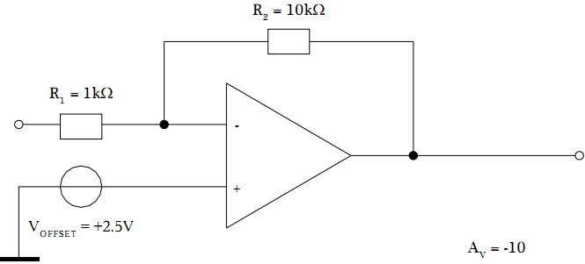It’s rare for an amplifier to have 27.5V (usually 5…12…15 V)

Если напряжение питания +/-30 В, то на выходе вполне может быть 2.5*(10+1)=27.5V

Но поскольку такой усилитель – большая редкость (обычно напряжение питания 5…12…15 В), то на выходе будет плюс напряжение питания 9режим насыщения)

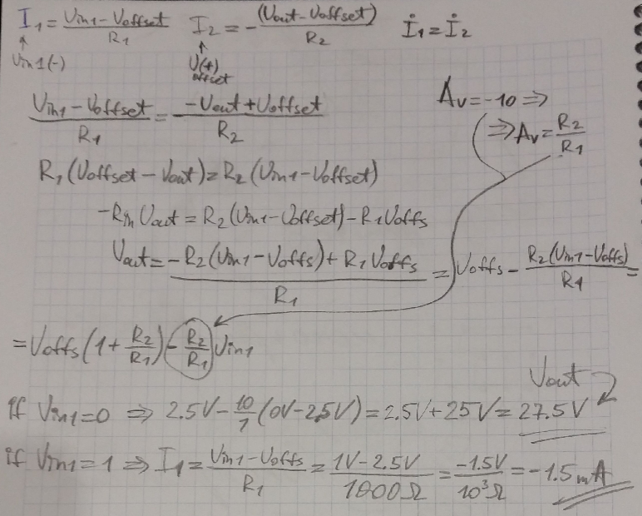

**• Calculate the current IR1 @ VIN- = +1Vdc:**

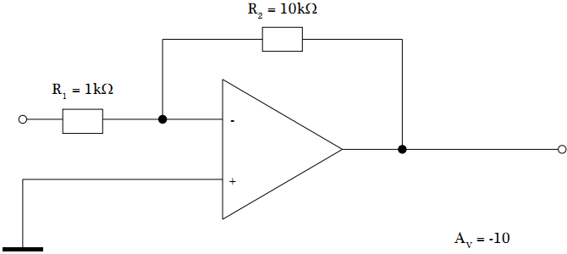



**7. Operational Amplifier – Comparator Part I**

**• What is right? For a zero level comparator**

a) Vout is positive as soon as Vin is positive --->>> right

b) Vout is positive as soon as Vin in negative

**• For which type of comparator the following is true?**

VOUT is positive as soon as VIN is positive **--->>>** For a zero level comparator

**• Draw Vin = f(t) and Vout = f(t) simultaneously; take care about the scale:**

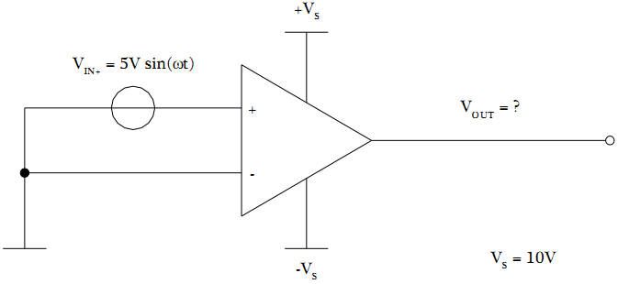

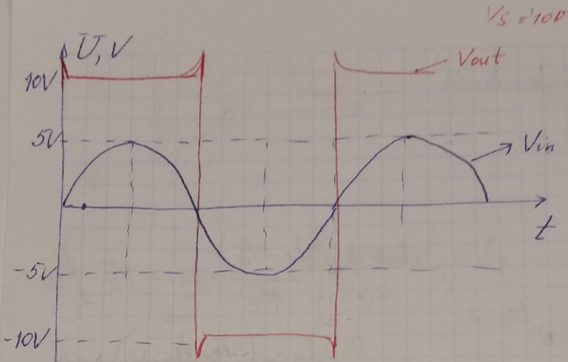

**• Draw the influence of the slew rate on the output voltage; use the drawing above**

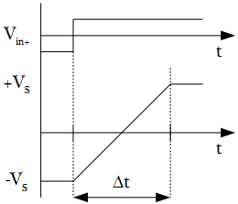 SR=2*pi*f*V (зависит от частоты сигналов и приложенного напряжения)

**8. Operational Amplifier – Comparator Part II**

**• What is right? For a non-zero level comparator**

a) Vout is positive as soon as Vin is higher than Vref ----->>> correct

b) Vout is positive as soon as Vin is lower than Vref

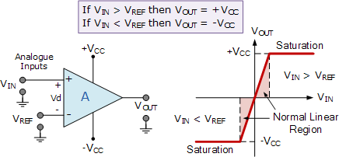

<http://www.electronics-tutorials.ws/opamp/op-amp-comparator.html>

**• Calculate the reference voltage Vref:**

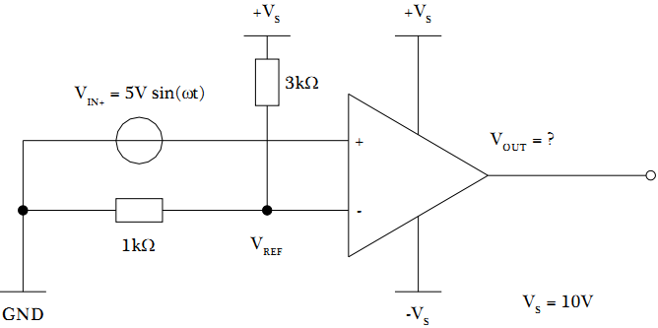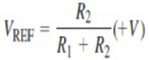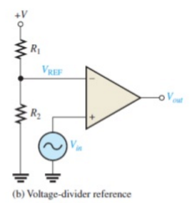

Vref=[ R2/(R1+R2) ] * Vs = (1000/4000)*10=2.5 V

<http://www.electronics-tutorials.ws/opamp/op-amp-comparator.html>

**• Calculate the reference voltage Vref:**

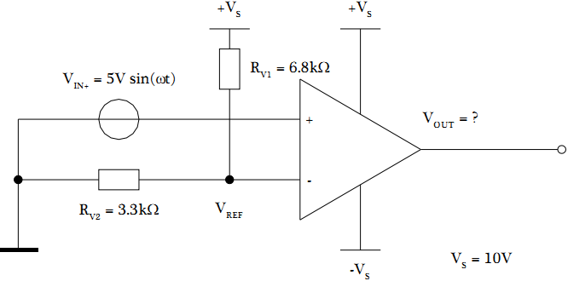 Vref=[ Rv2/(Rv1+Rv2) ] * Vs = (3300/10100)*10=3.267 V

**• What is right?**

**If Vref is variable**

a) the period of Vout is variable

b) the duty cycle of Vout is variable ---->>>> right

**• What has to be done to increase the on-time of the output voltage?**

Capacitor into the line to (-)

**• What has to be done to increase the off-time of the output voltage?**

Capacitor into the line to (-)

**9. Operational Amplifier – Summing Amplifier Part I**

**• What is the basic circuit for a summing amplifier?**

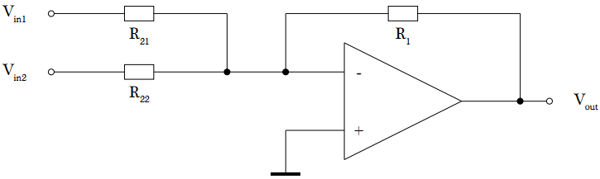

**• Draw a summing amplifier with three input voltages:**

Just add third R23 to the circuit above

**• What is the general equation for the summing amplifier from above**:  = R23

**10. Operational Amplifier – Summing Amplifier Part II**

**• What is the ratio between the feedback resistance and the input resistances of an averaging amplifier with three different input voltages?**

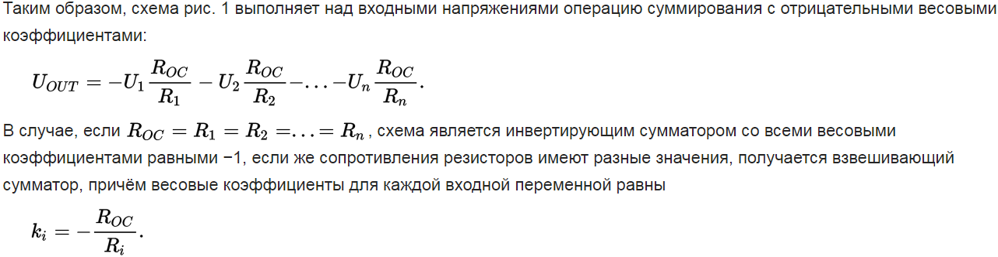

Для каждого R1, R2 …. Ri отдельный k (ratio), т.е. k1, k2…ki

**• Calculate the value of the output voltage:** ??????????????? summing ~~or averaging~~

**VIN1 = +10mV VIN2 = +20mV VIN3 = +70mV**

**RIN1 = 1kOhm RIN2 = 1kOhm RIN3 = 1kOhm RF = 1kOhm**

Summing

Vout = - [Rf/Rin1]*(Vin1+Vin2+Vin3) = - (Vin1+Vin2+Vin3) = -100mV

Не надо делать (-Vin1-Vin2-Vin3), т.к. минус в самом начале формулы – это и есть факт подключения к минусу у компаратора

**• Calculate the value of the output voltage:** ??????????????? ~~summing or~~ averaging

**VIN1 = +10mV VIN2 = +20mV VIN3 = +70mV**

**RIN1 = 1kOhm RIN2 = 1kOhm RIN3 = 1kOhm RF = 10kOhm**

Averaging – это суммирование с одинаковыми весовыми коэффициентами

Vout = - [Rf/Rin1]*(Vin1+Vin2+Vin3) = - (10/1)*(100)= -1V

**• Write down the general equation to calculate the value of the output voltage:**

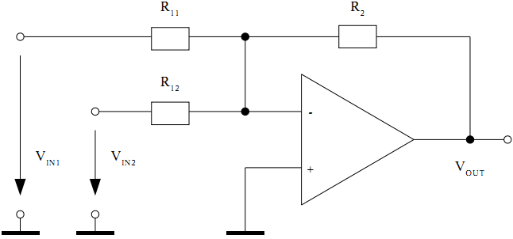

1. General equation for Summing Amplifier



1. If R21=R22=R



1. If (n*R1) = R21 = R22



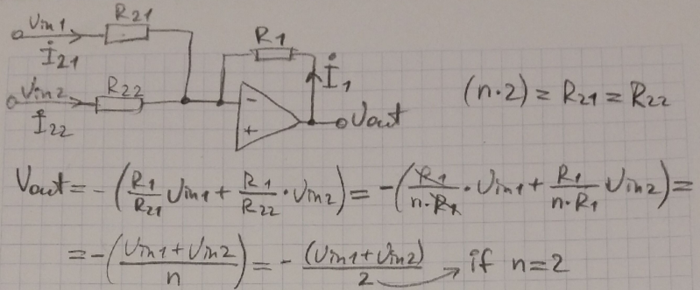

**• Calculate the value of VOUT for VIN1 = 10mV and VIN2 = 90mV if R2=R11=R12**

Vout=-(10mV+90mV)=-100mV

**10. Operational Amplifier – Summing Amplifier Part II**

**• What are the necessary resistance ratios to get an averaging amplifier?**



**• Calculate the value of output voltage VOUT for VIN1=10mV and VIN2=90mV, use resistance ratios from above**

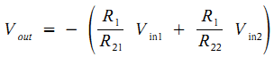

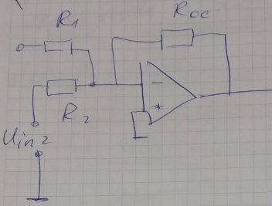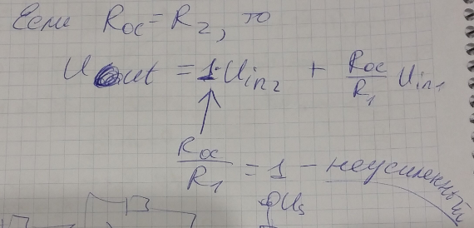

**• See the figure in the first question of chapter 10. What has to be done to add a constant offset voltage to the output voltage; draw the circuit:**

Add voltage sources

**• See the figure in the first question of chapter 10. What has to be done to add VIN2 as an unamplified offset voltage to the output voltage?**

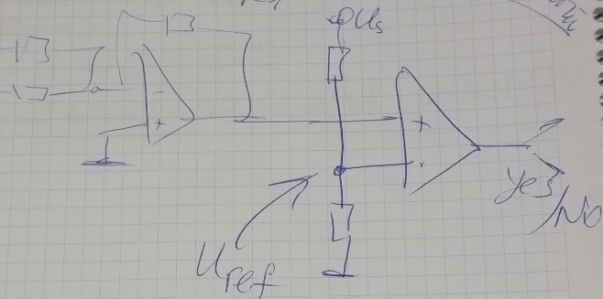

**1.2. Task 2 – Characteristic Parameters**



**Please calculate:**







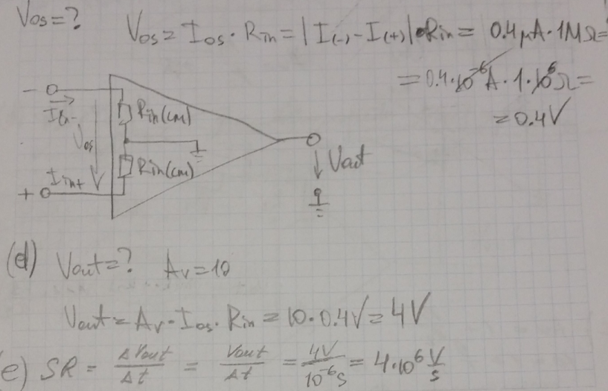

**1.3. Task 3 – Negative Feedback**

**a) Operational amplifier circuits are based on a negative feedback. What are the main purposes of negative feedback – name at least two different points! (2 points)**

**Negative feedback stabilizes against almost any type of disturbance.**

The use of negative feedback reduces the gain, but most other rationales favor its use. Part of the output signal is taken back to the input with a negative sign.

Why would you feed back a negative signal from the output which cancels part of the input, reducing the gain?

Because:

* It helps to overcome distortion and nonlinearity.
* It flattens frequency response or allows you to tailor it to a desired frequency response curve.
* It makes properties predictable, less dependent on temperature, manufacturing differences or other internal properties of the active device.
* Circuit properties are dependent upon the external feedback network and are thus easily controlled by external circuit elements.
* Circuit design can concentrate on function and not the details of operating point selection, biasing, and the other details characteristic of discrete transistor amplifier design.



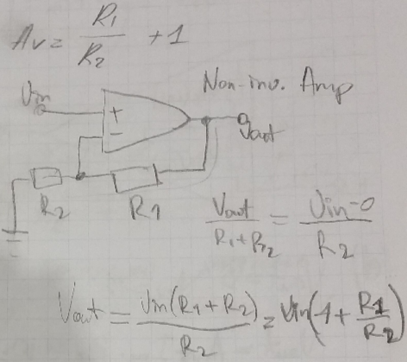

**c) What has to be changed in the circuit of task b) to get a voltage follower?**

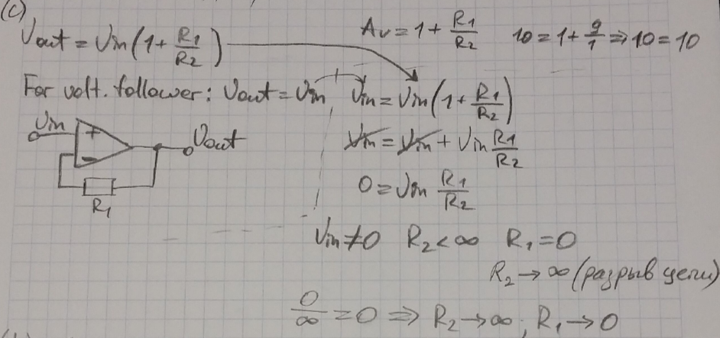

**d) What is the maximum input voltage of the voltage follower in order to ensure a linear output**

**range? (2 points)**



**2.1. Task 1 – Summing Amplifiers**

**Figure below shows the basic circuit of a summing amplifier.**

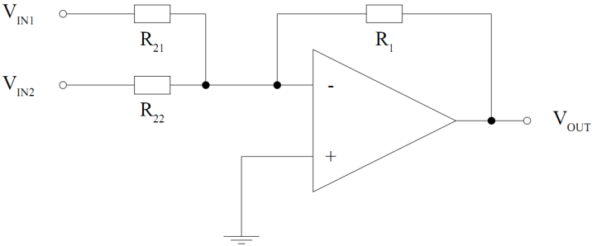

**a) Designate R1, R21 and R22 for VOUT = - (VIN1 + VIN2)** all resistors 🡪 1k or 2k, or 3k as you like

**b) Designate R1, R21 and R22 for VOUT = - 0.5 (VIN1 + VIN2)** R1=1к, R21=2к, R22=2к

**c) VOUT should be low pass filtered by a passive filter with a cut-off frequency of 1kHz @ Cf = 220µF. Calculate the necessary filter resistor. (2 points)**

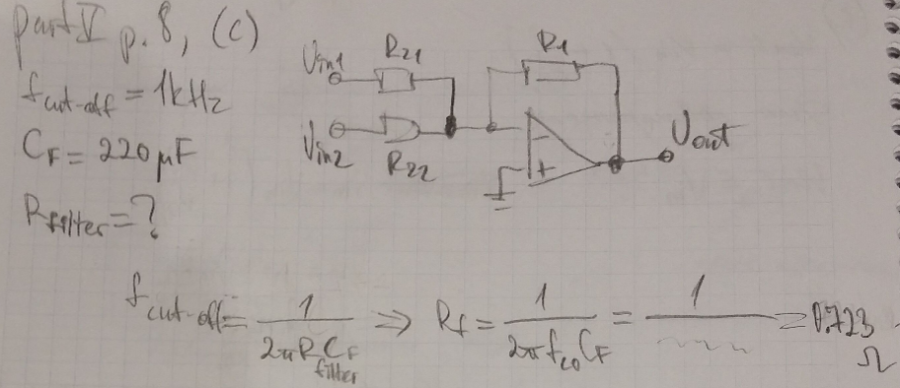

**d) By which circuit can be detected that VOUT is greater than a certain reference voltage? Draw**

**the circuit! (4 points)**



**2.2. Task 2 – Active Filters**

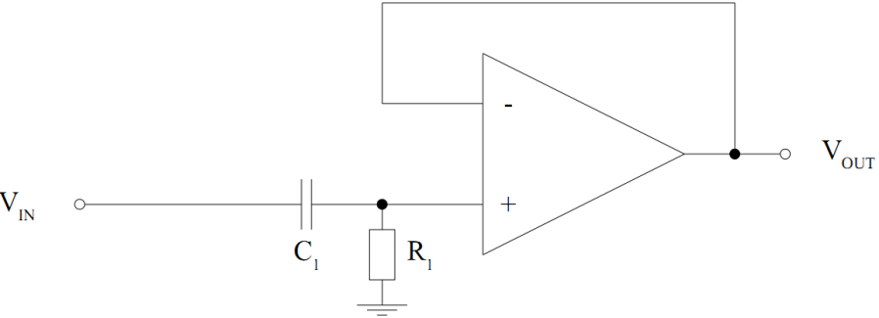**Figure 3: single-pole active high-pass filter**

**a) How big is the voltage gain of the filter when the frequency of the input voltage is at least ten**

**times higher than the cut-off frequency of the filter? (2 points)**

Av=1 (OdB) (single-pole or first order - it’s when there’s one CR, two-pole – when two CRs and so on)

**b) Draw the circuit of a single-pole active low-pass filter. (4 points) ????????**

same thing, just switch places for R and C

**c) What are the roll-offs of an active single-pole and an active two-pole filter? (4 points) ????????**

Same thing as Bode diagrams. For single-pole (first order) there’s a slope 6 dB/octave, for two-pole it’s 12 dB/octave <https://en.wikipedia.org/wiki/Roll-off>

**2.3. Task 3 – Oscillators (генераторы, излучатели)**

**a) Name the two main characteristics of an oscillator based on an op-amp. (2 points)**

frequency and form of output oscillations (harmonic (sin/cos) or rectangular)

harmonic (sin/cos) 🡪 oscillator

square waves 🡪 multivibrator

**b) Which op-amp oscillator is able to generate a sinusoidal output voltage? (2 points)**

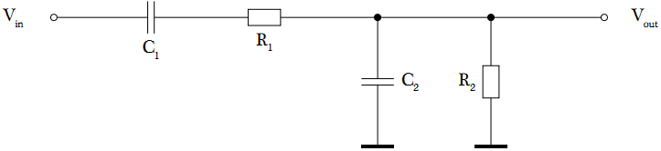

**c) Which possibilities exist to solve the start-up problem of an active oscillator? (4 points)**

The Wien-Bridge Oscillator start-up problem:

* while starting-up the lead-lag circuit doesn't oscillate
* the input/output voltage of the op-amp is zero
* the output voltage must be generated by amplifying the input offset voltage
* the voltage gain for starting-up must be greater than in normal operation mode

=> variable voltage gain

=> manually controlled, self controlled or digitally controlled (see circuits below, respectively)

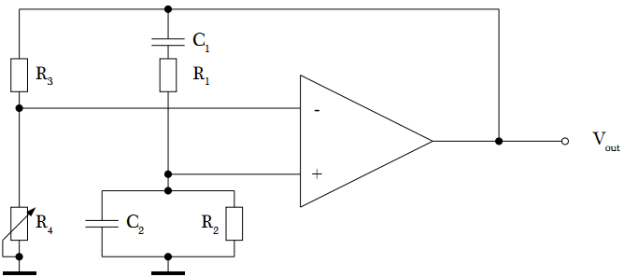 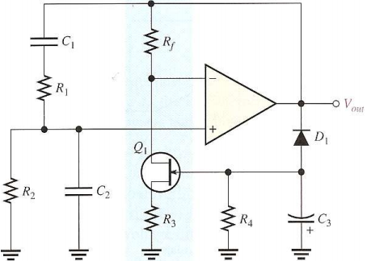

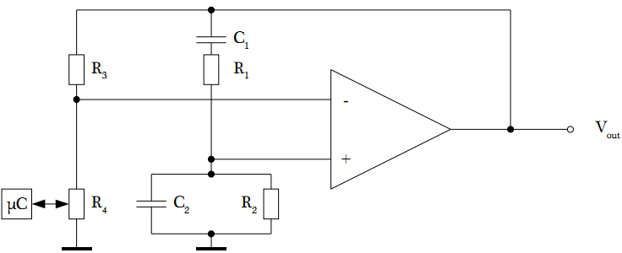

**d) Which oscillator is shown in Figure 4(below)? (2points)** ----->>>>> square wave oscillator

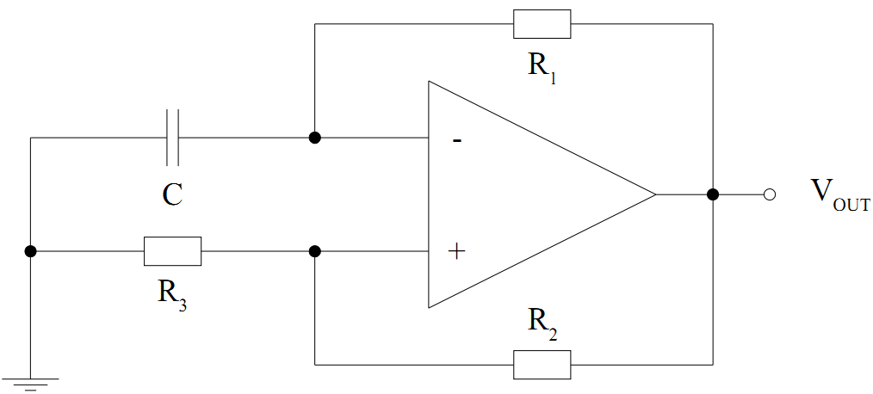

**Other possible questions:**

**Operational amplifiers** are linear devices that have all the properties required for nearly ideal DC amplification and are therefore used extensively in signal conditioning, filtering or to perform mathematical operations such as add, subtract, integration and differentiation.

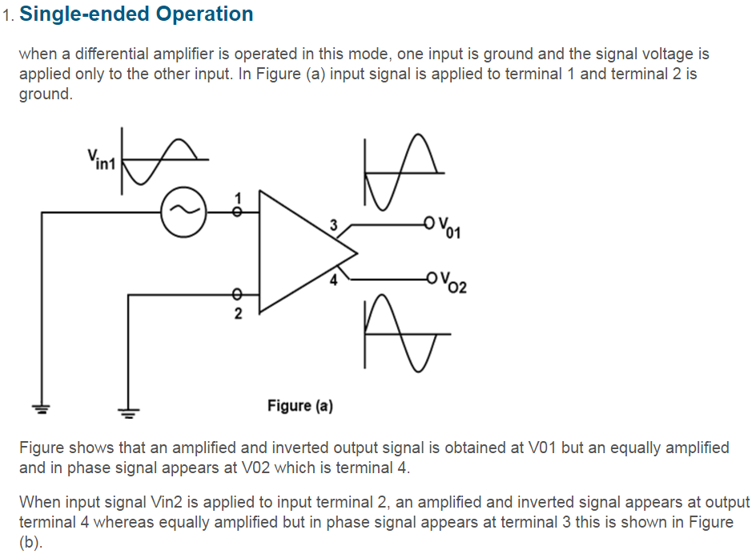

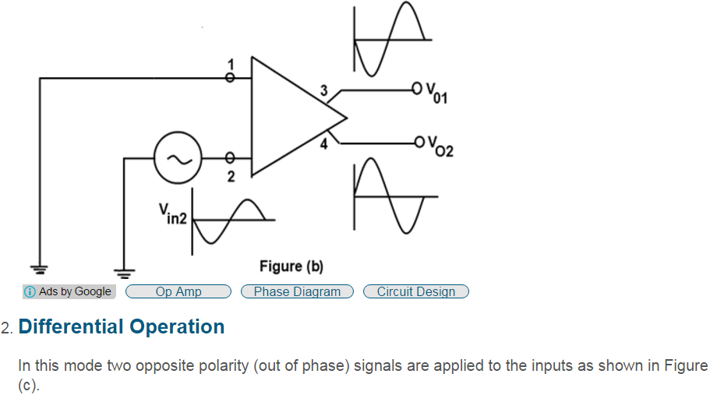

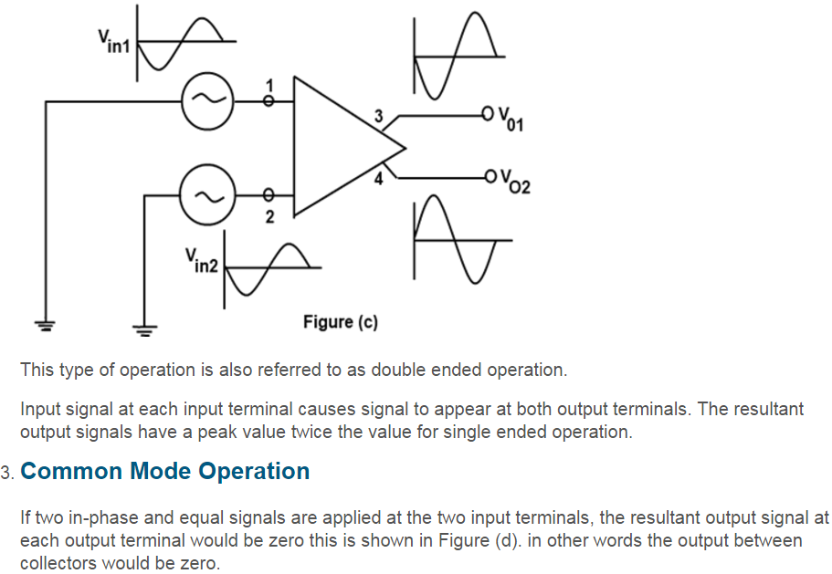

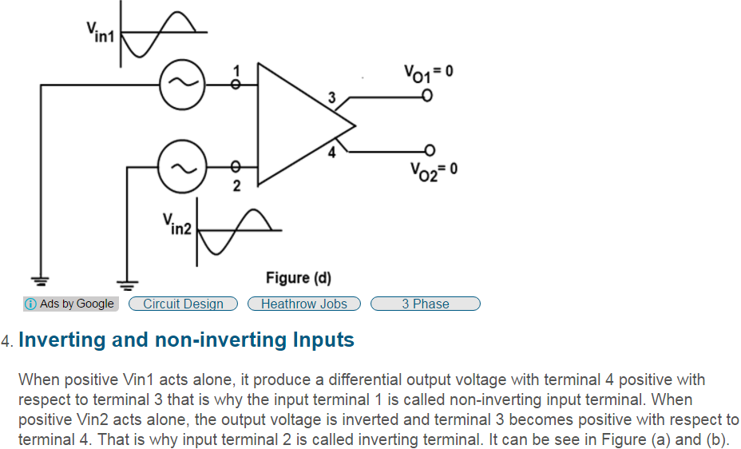

**Negative Feedback and Closed loop voltage gain AV**

**Negative Feedback** is the process of “feeding back” a fraction of the output signal back to the input, but to make the feedback negative, we must feed it back to the negative or “inverting input” terminal of the op-amp using an external **Feedback Resistor** called Rƒ. This feedback connection between the output and the inverting input terminal forces the differential input voltage towards zero.

This effect produces a closed loop circuit to the **amplifier** resulting in the gain of the amplifier now being called its **Closed-loop Gain**. Then a closed-loop inverting amplifier uses negative feedback to accurately control the overall gain of the amplifier, but at a cost in the reduction of the amplifiers gain.

This negative feedback results in the inverting input terminal having a different signal on it than the actual input voltage as it will be the sum of the input voltage plus the negative feedback voltage giving it the label or term of a Summing Point. We must therefore separate the real input signal from the inverting input by using an **Input Resistor**, Rin.

As we are not using the positive non-inverting input this is connected to a common ground or zero voltage terminal as shown below, but the effect of this closed loop feedback circuit results in the voltage potential at the inverting input being equal to that at the non-inverting input producing a Virtual Earth summing point because it will be at the same potential as the grounded reference input. In other words, the op-amp becomes a “differential amplifier”.

**Stokes shift** is the difference (in wavelength or frequency units) between positions of the band maxima of the absorption and emission spectra (fluorescence and Raman being two examples) of the same electronic transition. It is named after Irish physicist George G. Stokes.

When a system (be it a molecule or atom) absorbs a photon, it gains energy and enters an excited state. One way for the system to relax is to emit a photon, thus losing its energy (another method would be the loss of energy as heat). When the emitted photon has less energy than the absorbed photon, this energy difference is the Stokes shift.

The Stokes shift is the result of two actions: Vibrational relaxation or dissipation and solvent reorganisation. A fluorophore is a dipole, surrounded by water molecules. When a fluorophore enters an excited state, its dipole moment will change, but water molecules will not be able to adapt this quickly. Only after vibrational relaxation, will there will be a realignment of their dipole moments.

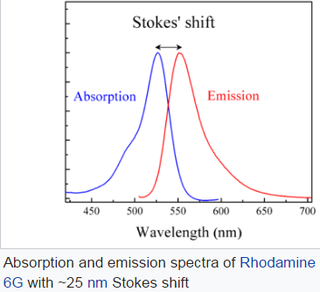**LED ->**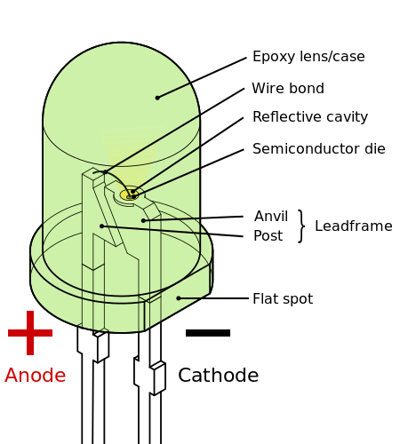

A **light-emitting diode** (**LED**) is a two-lead semiconductor light source. It is a p–n junction diode, which emits light when activated. When a suitable voltage is applied to the leads, electrons are able to recombine with electron holes within the device, releasing energy in the form of photons. This effect is called electroluminescence, and the color of the light (corresponding to the energy of the photon) is determined by the energy band gap of the semiconductor.

An **organic light-emitting diode** (**OLED**) is a light-emitting diode (LED) in which the emissive electroluminescent layer is a film of organic compound that emits light in response to an electric current. This layer of organic semiconductor is situated between two electrodes; typically, at least one of these electrodes is transparent. OLEDs are used to create digital displays in devices such as television screens, computer monitors, portable systems such as mobile phones, handheld game consoles and PDAs. A major area of research is the development of white OLED devices for use in solid-state lighting applications.

A **photoresistor** is a light-dependent resistor which slowly loses its resistance when exposed to high levels of ultraviolet light. As a result, photoresistors convert light energy into electrical energy. Photoresistors are used in a wide variety of devices to detect the presence of light, control a device, or activate a system. They are usually dependent on external light sources, although they can be connected to a system that produces its own light

**How a Photoresistor Works** Photoresistors are made of highly resistant semiconductors that are sensitive to high photonic frequencies. As photons (light particles) come in contact with the semiconductor, they cause electrons that were bound to the metal to jump to another piece of the semiconductor. As more photons hit the semiconductor, more electrons are knocked loose. This creates a very effective conductive flow of electricity that only travels through the semiconductor when in the presence of light.

**Applications** Photoresistors are used for a wide variety of purposes, all of which require light to determine whether a device should be on, off, or set to a particular position. Photoresistors are responsible for turning street lights on/off and measuring the amount of light that a camera picks up. They are also used in some types of alarms and clocks. Photoresistors are used in dynamic compressors to control gain reduction and can be calibrated to respond to infrared light.

**Advantages**. They are completely dependent on how much light they receive. This means that external forces will not interfere with the devices that they are connected to. A photoresistor is also very simple because it is merely a semiconductor with a conductive pathway connected to one end in order to transfer a current from the semiconductor to the external device that it is powering.

They are small enough to fit into virtually any electronic device and are used all around the world as a basic component in many electrical systems. Also, photoresistors are simply designed and are made from materials that are widely available, allowing hundreds of thousands of units to be produced each year.

**Disadvantages** Most photoresistors cannot detect low light levels and may not work in certain conditions or circumstances. Photoresistors are also slow to respond to new levels of light and may take up to several seconds to recognize the change. This is because electrons are still moving through the semiconductor and take a few seconds to slow down or speed up.

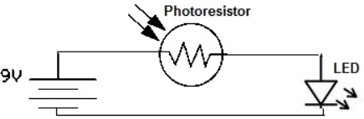

A **photodiode** is a semiconductor device that converts light into current. The current is generated when photons are absorbed in the photodiode. A small amount of current is also produced when no light is present. Photodiodes may contain optical filters, built-in lenses, and may have large or small surface areas. Photodiodes usually have a slower response time as their surface area increases. **The common, traditional solar cell used to generate electric solar power is a large area photodiode.** Silicon photodiodes are semiconductor devices responsive to high energy particles and photons. Photodiodes operate by absorption of photons or charged particles and generate a flow of current in an external circuit, proportional to the incident power. Silicon photodiodes are utilized in such diverse **applications** as spectroscopy, photography, analytical instrumentation, optical position sensors, beam alignment, surface characterization, laser range finders, optical communications, and medical imaging instruments.

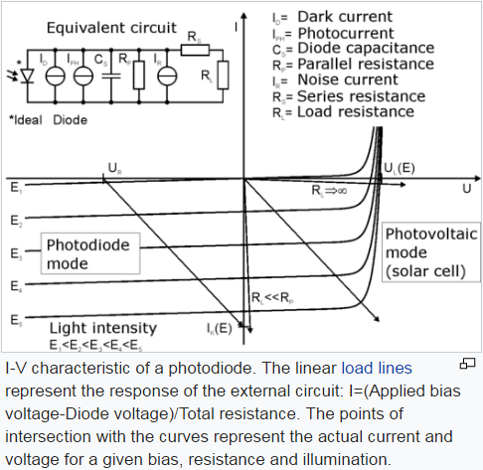

A **phototransistor** is a light-sensitive transistor. A common type of phototransistor, called a photobipolar transistor, is in essence a bipolar transistor encased in a transparent case so that light can reach the *base–collector junction*.

**Applications** Phototransistors are used for a wide variety of applications. In fact, phototransistors can be used in any electronic device that senses light. For example, phototransistors are often used in smoke detectors, infrared receivers, and CD players. Phototransistors can also be used in astronomy, night vision, and laser range-finding.

**Advantages** Phototransistors have several important advantages that separate them from other optical sensors. They produce a higher current than photodiodes and also produce a voltage, something that photoresistors cannot do. Phototransistors are very fast and their output is practically instantaneous. They are relatively inexpensive, simple, and so small that several of them can fit onto a single integrated computer chip.

**Disadvantages** While phototransistors can be advantageous, they also have several disadvantages. Phototransistors made of silicon cannot handle voltages over 1,000 Volts. They do not allow electrons to move as freely as other devices, such as electron tubes, do. Also, phototransistors are also more vulnerable to electrical surges/spikes and electromagnetic energy.

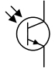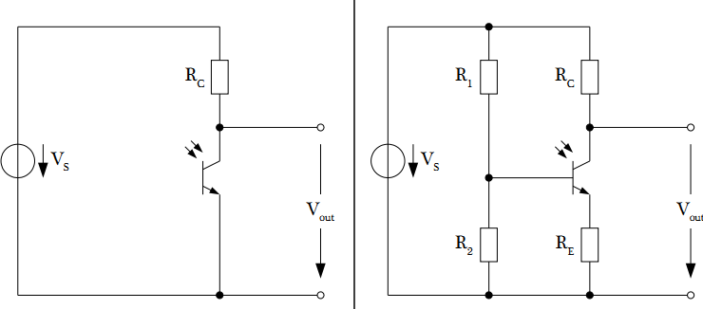

In electronics, an **opto-isolator**, also called an **optocoupler**, **photocoupler**, or **optical isolator**, is a component that transfers electrical signals between two isolated circuits by using light. Opto-isolators prevent high voltages from affecting the system receiving the signal. Commercially available opto-isolators withstand input-to-output voltages up to 10 kV and voltage transients with speeds up to 10 kV/μs.

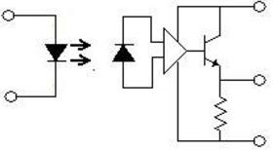

A **solar cell**, or **photovoltaic cell** (previously termed "solar battery"[[1]](https://en.wikipedia.org/wiki/Solar_cell#cite_note-Shockley--Queisser_limit-1)), is an electrical device that converts the energy of light directly into electricity by the photovoltaic effect, which is a physical and chemical phenomenon.[[2]](https://en.wikipedia.org/wiki/Solar_cell#cite_note-chemistryexplained.com-2) It is a form of photoelectric cell, defined as a device whose electrical characteristics, such as current, voltage, or resistance, vary when exposed to light. Solar cells are the building blocks of photovoltaic modules, otherwise known as solar panels.

**Solar panel** refers to a panel designed to absorb the sun's rays as a source of energy for generating electricity or heating. The most common application of solar panels is solar water heating systems.

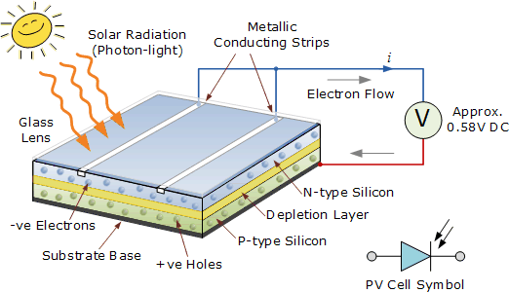

Pros and Cons of Monocrystalline vs. Polycrystalline Solar Panels

There are 3 types of technology utilized in the solar panels available on the market today, these are monocrystalline, polycrystalline, and thin film amorphous.

As the names suggest Monocrystalline and Polycrystalline are both types of solar cells that are made from crystalline silicon.

Both monocrystalline and polycrystalline solar cells are very similar in performance. What really determines your outcome in terms of system performance over the lifetime of the solar panel is a lack of defects in the manufacturing process and having a company that will replace the panels if their performance falls below the warranted levels.

Thin film is a totally different technology. It is much less efficient and therefore uses much more roof space. Its one advantage is that it performs better in low light conditions, when there is partial shading of the system or in extreme heat.

## The key facts about each type of solar cell:

### Monocrystalline

**Overview and Appearance**  
This is the oldest and most developed of the three technologies. Monocrystalline panels as the name suggests are created from a single continuous crystal structure. A Monocrystalline panel can be identified from the solar cells which all appear as a single flat color.

**Construction**  
They are made through the Czochralski method where a silicon crystal ‘seed’ is placed in a vat of molten silicon. The seed is then slowly drawn up with the molten silicon forming a solid crystal structure around the seed known as an ingot. The ingot of solid crystal silicon that is formed is then finely sliced ingot what is known as a silicon wafer. This is then made into a cell.

The Czochralski process results in large cylindrical ingots. Four sides are cut out of the ingots to make silicon wafers. **A significant amount of the original silicon ends up as waste.**

### Polycrystalline

**Overview and Appearance**  
Polycrystalline or Multicrystalline are a newer technology and vary in the manufacturing process.

**Construction**  
Polycrystalline also start as a silicon crystal ‘seed’ placed in a vat of molten silicon. However, rather than draw the silicon crystal seed up as with Monocrystalline the vat of silicon is simply allowed to cool. This is what forms the distinctive edges and grains in the solar cell.

Polycrystalline cells were previously thought to be inferior to Monocrystalline because they were slightly less efficient, however, because of the cheaper method by which they can be produced coupled with only slightly lower efficiencies they have become the dominant technology on the residential solar panels market.

In November 2015 Trina Solar announced that it had produced a multi-crystalline cell with efficiency of 21.25%. This should allow them to produce polycrystalline modules with efficiencies between 18-20% a concept that was thought impossible as recently as 2013.

Underpinning the new record for p-type multicrystalline solar cells has been the continued quality improvements of multicrystalline wafers that have helped pushed standard 60-cell multicrystalline panels from 240W to 260W in recent years.

Polycrystalline are now very close to Monocrystalline cells in terms of efficiency.

### Thin Film

**Overview and Appearance**  
Thin film panels are a totally different technology to Mono and Polycrystalline panels. They are a new technology compared to Mono and Polycrystalline cells and would not be considered a mature technology as vast improvements in this technology are expected in the next 10 years.

A thin film panel can be identified as having a solid black appearance. They may or may not have a frame, if the panel has no frame it is a thin film panel.

**Construction**  
Thin film panels are made by depositing a photovoltaic substance onto a solid surface like glass. The photovoltaic substance that is used varies and multiple combinations of substances have successfully and commercially been used. Examples of the most common photovoltaic substances used are:

* Amorphous Silicon
* Cadmium Telluride (CdTe)
* Copper indium gallium selenide (CGIS)
* Dye-sensitized solar cell (DSC)

Each of the above are known as different panel 'types' but all fall under the umbrella of being a Thin Film panel.

**Performance**  
Thin film cells have got a reputation as being the ‘worst’ of the [solar panel](http://www.solarreviews.com/solar-panels/) technologies because they have the lowest efficiency. However, this is only because they have a lower power efficiency which only means they require the most space for the same amount of power. Since they are becoming the cheapest panels to produce because of the low material costs for thin film they are quickly becoming the more economically efficient panel types.

Depending on the technology, thin-film module prototypes have reached efficiencies between 7–13% and production modules operate at about 9%. Future module efficiencies are expected to climb close to the about 10–16%.

The market for thin-film PV grew at a 60% annual rate from 2002 to 2007. In 2011, close to 5% of U.S. photovoltaic module shipments to the residential sector were based on thin-film.

## Advantages of Monocrystalline solar panels

**1Monocrystalline solar panels have the highest efficiency rates since they are made out of the highest-grade silicon**. On October 2 2105, SolarCity announced that it has developed the world’s most efficient solar panels. The new panels convert more than 22% of sunlight into electricity.

**2**Just days later Panasonic announced it had trumped that achievement. A Panasonic solar panel has established a new world record module conversion efficiency of 22.5% on a commercial sized prototype using solar cells based on mass production technology. The test results were confirmed by the renowned Japanese National Institute of Advanced Industrial Science and Technology. The 72-cell, 270-watt prototype incorporates newly developed enhanced technology that will eventually be scaled into volume production.

**3**Panasonic also says it is introducing the HIT® N330, the latest addition to the company's high-efficiency hetero-junction photovoltaic module product line and its most powerful photovoltaic module to date. It will be available in the UK and other European markets starting in March, 2016. Manufactured at Panasonic's state-of-the-art, vertically integrated solar fabrication facilities in Malaysia, HIT® N330 features 19.7% module-level efficiency and a nominal power output of 330 watts.

**4**Monocrystalline silicon solar panels are space-efficient. Since these solar panels yield the highest power outputs, they also require the least amount of space compared to any other types. However, monocrystalline solar panels produce marginally more power per square foot of space used in an array and so.

**5**Monocrystalline Panels have a long lifespan. Most solar panel manufacturers put a 25-year warranty on their monocrystalline solar panels. Because both types of crystalline solar panels are made from crystalline silicon, a very inert and stable material it is very likely that these solar panels will last much longer then their 25 year warranty life.

**6**Monocrystalline solar panels tend to be more efficient in warm weather. With all solar cells electricity production falls as temperature goes up. However, this degradation of output is less severe in monocrystalline panels than polycrystalline solar panels. However, in practice the difference is very small. The level to which each solar panels production falls as temperature increase sis called the temperature co-efficient and is published with the specifications for each panel.

**Disadvantages of Monocrystalline solar panels**

**1**Monocrystalline solar panels are the most expensive. In recent years a rash in installation of polycrystalline ingot, cell and module production efficiencies have mean that polycrystalline solar panel have become more common and have benefited from costs advantages over mono panels. Most manufacturers that still make mono panels have targeted the premium end of the market.

## Advantages of Polycrystalline solar panels

**1The process used to make polycrystalline silicon is simpler and cost less**. The amount of waste silicon is less compared to monocrystalline.

**2Polycrystalline solar panels tend to have slightly lower heat tolerance than monocrystalline solar panels**. Polycrystalline solar panels will tend to have a higher temperature co-efficient than solar modules made with mono cells. This means that as heat increased output for this type of cell will fall less. However, in practice these differences are very minor.

## Disadvantages of Polycrystalline solar panels

**1The efficiency of polycrystalline-based solar panels is typically 14-16%**. Because of lower silicon purity, polycrystalline solar panels are not quite as efficient as monocrystalline solar panels.

**2Lower space-efficiency**. You generally need to cover a larger surface to output the same electrical power as you would with a solar panel made of monocrystalline silicon. However, this does not mean every monocrystalline solar panel perform better than those based on polycrystalline silicon.

**3**Monocrystalline and thin-film solar panels tend to be more aesthetically pleasing since they have a more uniform look compared to the speckled blue color of polycrystalline silicon.

## Advantages of Thin Film solar panels

**1Mass-production is simple**. This makes them and potentially cheaper to manufacture than crystalline-based solar cells.

**2**Their homogeneous appearance makes them look more appealing.

**3**Can be made flexible, which opens up many new potential applications.

**4**High temperatures and shading have less impact on solar panel performance.

**5In situations where space is not an issue, thin-film solar panels can make sense**.

**Disadvantages of Thin Film solar panels**

**1**Thin-film solar panels are in general not very useful for in most residential situations. They are cheap, but they also require a lot of space. SunPower's monocrystalline solar panels produce up to four times the amount of electricity as thin-film solar panels for the same amount of space.

**2**Low space-efficiency also means that the costs of PV-equipment (e.g. support structures and cables) will increase.

**3**Thin-film solar panels tend to degrade faster than mono-crystalline and polycrystalline solar panels, which is why they typically come with a shorter warranty.

